PAX Case Cir. Connector
Amphe-Lite AL06F21-41P “ATA-90 rev-b, wire colors”

TEC Power 2 pins
p TEC Power + gray
q TEC Power - black

TEC Control 6 pins
a Heat Sink Temp black Z (twisted pairs)
G Heat Sink Temp red Z
b Pax Temp black Y
H Pax Temp white Y
c Airstream Temp black X
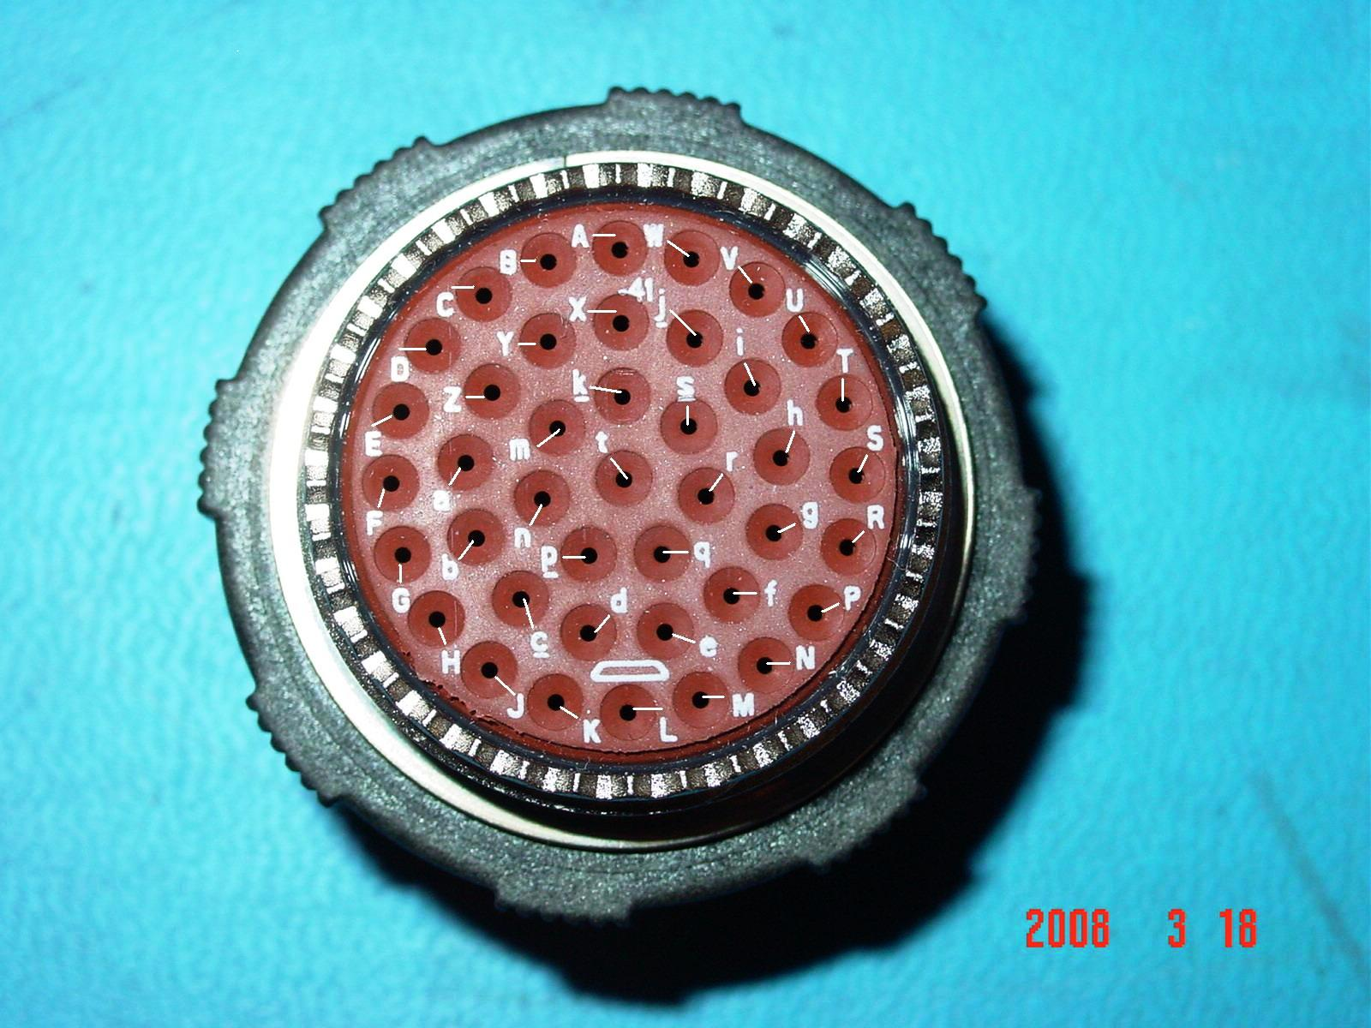
J Airstream Temp green X

Cryo Power 4 pins
d Cryo Power + red
K Cryo Power + white
e Cryo Power - black
M Cryo Power - green
Shield grnd to pax case gray

Cryo Temp 2 pins
D Cryo Temp 1 white
E Cryo Temp 2 black
Shield grnd to pax case gray

Dewar Temp 2 pins
U Dewar Temp 1 red
T Dewar Temp 2 black
Shield grnd to pax case gray

PAX Control 12 pins
Z Grnd OTXTEC black Z
Y +5V OTXTEC red Z
B Grnd OTX laser / PAM black Y
C +6V OTX laser / PAM yellow Y
k Gnd Sense black
s +6 Sense green
X +5 Sense white
m -6 Sense black
i Grnd OTXTEC black X
j +5V OTXTEC brown X
V Grnd OTX / PAM black W
W -6V OTX / PAM blue W Back View (inside Pax Case) A position is at 12:00 / L position is at 6:00

Ion Pump Control 6 pins
f Current monitor blue
g External reset white
h Power +12 VDC red
r Power com black
P Fault high voltage brown
R Fault blown fuse green

Pax Case/ Rim Box Ground Wire 1 pin
L Grounded to case green

Connector Positions Not Used
A
N
n
S
t

